



London, Kings College
Centre Handbook
2026

Contents

Contents 2
Summary 3
The Centre 3
Location 4
Airport Transfers: 4
Campus Map……………………………………………………………………………………………………………………………..5
Local Amenities 6
Accommodation 8
Room Allocation 8
Housekeeping 8
Key Loss 8
Deposits 8
Meals 9
Meal times 9
King’s College - Sample Menu 10
Technology 12
Security 12
Safety 12
Teaching 13
Placement tests Error! Bookmark not defined.
Programme 14
A typical day for students 14
Kings College, London Sample Programme - Summer 2025 16
Facilities 17
Evening entertainment 17

Thank you very much for your interest in our King’s College, London centre. We hope you find everything you need in the following pages but if you have any questions or specific requests then please get in touch with us at Head Office on +44 (0)1244 577995.
The contents of this handbook are updated regularly. The latest version will be sent before your arrival.
We look forward to a successful summer 2026 at King’s College London.

Summary


Amazing city centre location

University

Ensuite accommodation
Short Transfers

The Centre

King’s College is a public research university located in the heart of London. It is an open urban university campus.

It is an open site with high security. With CCTV on campus, the residences have swipe card entry systems for access. There are residence officers 8am-9pm and overnight security 8:30pm-8:30am.

There is a total of 160 beds made up of single ensuite accommodation in flats of 6 rooms. In each flat there is a kitchen on every floor that can be accessed, but the students will not be allowed to use any appliances, but the fridges, and common areas on campus that can be used.

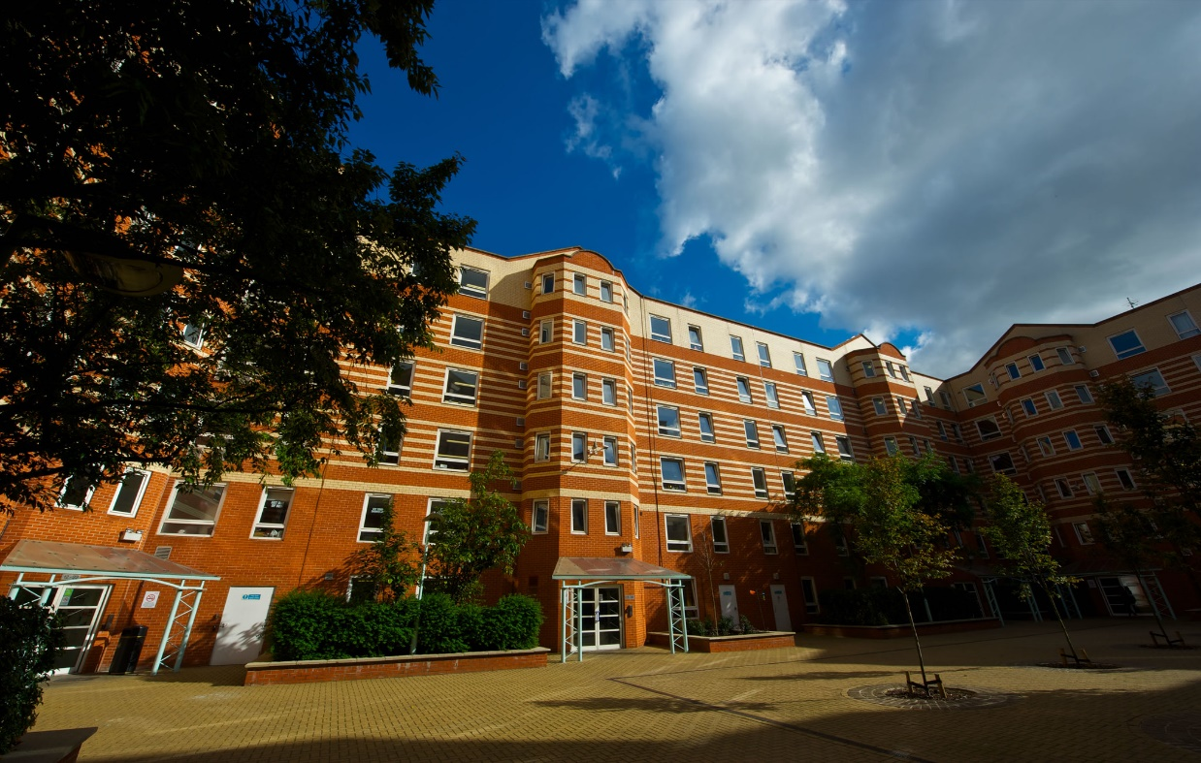
In this centre, we accept students travelling in groups from 13 to 17 years old.

Location

Stamford St, London SE1 9NH

Telephone Number - +44(0)20 78365454

Population of London - 8.9 Million

King’s College Waterloo campus is situated in zone 1, just 5 minutes’ walk to Waterloo station.

London is England’s capital city, set on the River Thames, is a 21st Century city with history stretching back to Roman times.

Airport Transfers:

London Gatwick: 1 hour
London Heathrow: 1 hour 10 minutes
London Stanstead: 1 hour 10 minutes
London City: 40 minutes
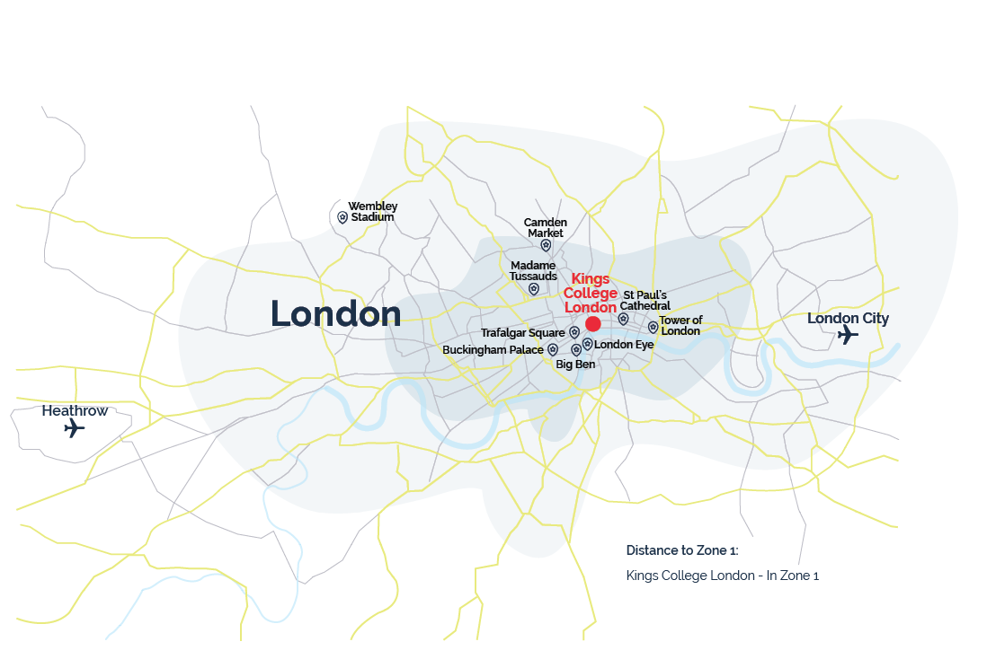
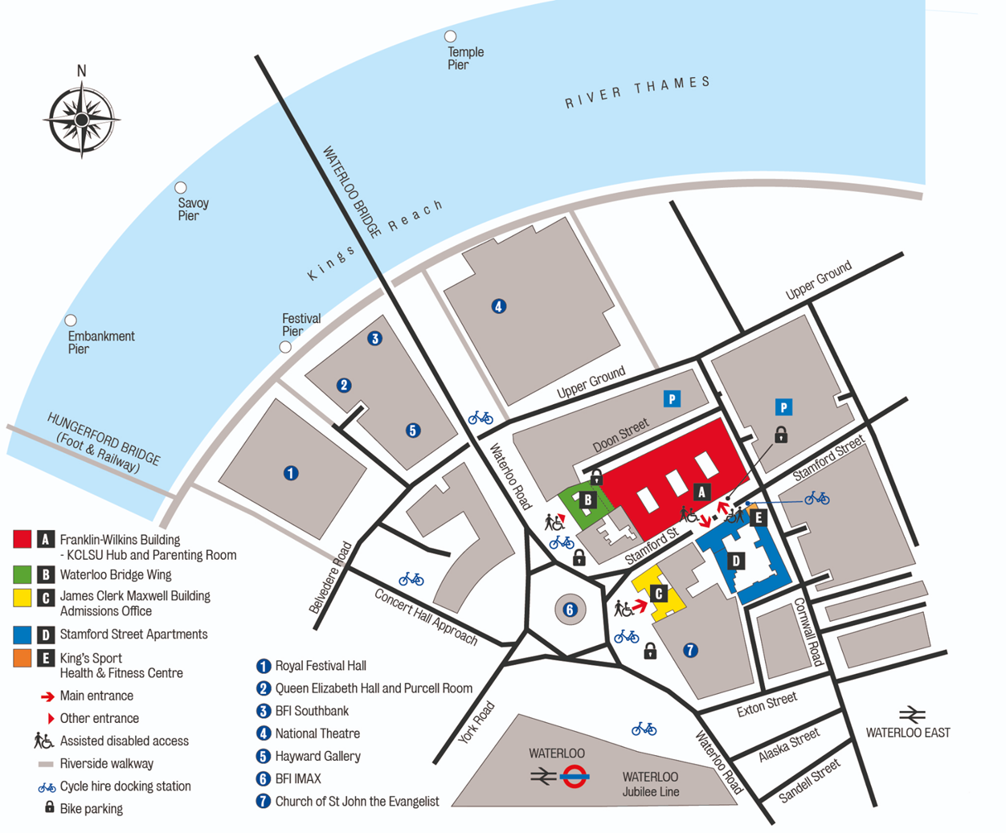

Local Amenities

Post Office
Cornwall Road Post Office
Address: 62 Cornwall Road, London, SE1 9PU (0.2 miles / 3 minute walk)

Supermarket
Costcutter
Address: Costcutter, 62 Cornwall Rd, East SE1 9PP (0.1 miles / 3 minute walk)

ATM
Waterloo Station
Address: Waterloo Station, Bishops’, London, DE1 8BL (0.4 miles / 8 minutes’ walk)

Chemist
Waterloo Station – Boots
Address: Waterloo Station, Bishops’, London, DE1 8BL (0.2 miles / 6 minutes’ walk)

Hospital
St Thomas Hospital
Address: St Thomas Hospital, Lambeth Palace Rd, Bishops’, London SE1 7PB (0.3 miles / 7 minutes’ walk)
Telephone: 020 7188 7188
N.B. - If a student is ill and requires a doctor, a group leader and a UKLC staff member will take the student to the St Thomas Hospital. The student will be required to fill out a temporary patient form and will be seen on the same day.

Dentist
Tooth Dental Care
Address: 26 Lower Marsh, London SE1 7RJ (0.5 miles / 11 minutes’ walk)
Telephone: 020 7928 2875

Bus Stops
Waterloo Station – Tension way (Stop K) (285 ft / 1-minute walk)

Train Stations
Waterloo Station
Address: Waterloo Station, Bishops’, London, DE1 8BL (0.2 miles / 6 minutes’ walk)

Taxi Companies
Addison Lee: 020 7407 9000
Camberwell Cars: 020 7703 4461

Coffee Shops
Costa Coffee
Costa Coffee serves a variety of light bites and main meals with relaxed surroundings and high-quality coffee.
Address: BFI IMAX, Charlie Chaplin Walk, London, SE1 8XR
Walking distance from Waterloo Campus: 0.3 miles (6 minutes’ walk)

Beany Green
A wide selection of breakfasts, lunches and snacks, House serves tip top coffee and tea, smoothies and fresh juices as well as locally homemade cakes.
Address: Belvedere Rd, Bishops’, London, SE1 8XX
Walking distance from Waterloo Campus: 0.4 miles (9 minutes’ walk)

Restaurants
Brasserie Blanc
Upscale chain brasserie serving a classically French menu devised by celebrity chef Raymond Blanc.
Address: 9 Belvedere Rd, Bishops’, London, SE1 8YL Walking distance from Waterloo Campus: 0.3 miles (6 minutes’ walk)

The Archduke
Steak restaurant and wine bar under railway arches with free jazz on Fridays and Saturdays.
Address: 135 Concert Hall Approach, Bishops’, London, SE1 8XU Walking distance from Waterloo Campus: 0.4 miles (7 minutes’ walk)

Azzurro
Relaxed restaurant serving Italian staples under the soaring exposed brickwork of a railway arch.
Address: 1 Sutton Walk, Bishops’, London, SE1 7ND
Walking distance from Waterloo Campus: 0.3 miles (7 minutes’ walk)

Accommodation

The University has one residential house all with single ensuite rooms. The accommodation is called Stamford Street Apartments and has a kitchen in every flat of 6 bedrooms. The kitchen can be accessed, but the students will not be allowed to use any appliances, only the fridges.

All bedding and towels are provided.

Room Allocation

We divide the students up according to their age, gender and group where possible. The Group Leader will be in charge of assigning the rooms. Group leaders will stay in the same house as their students. Room allocation is normally done on arrival. If you would like any further information on this, please contact us.

Housekeeping

Bedding and towels are changed once every 4 days. Bedrooms and bathrooms are deep cleaned every 4 days. Rooms are checked and bins emptied daily Monday-Friday.

There are washing machine and tumble dry facilities located in Stamford Street Apartments that are operated with an app. The instructions and prices are displayed in the laundry room. The students must provide their own washing powder.

Key Loss
All students and group leaders will receive their own key card for the duration of their stay. If any key is lost or not returned before departure, there will be a £35 fee for a replacement.

Deposits
We will ask each student for a deposit of €25/£25 on arrival. We will check their rooms before they arrive and before they leave, returning the money if everything is in order. If there is damage to the houses and nobody admits fault, we will ask everyone in the house to share the cost.
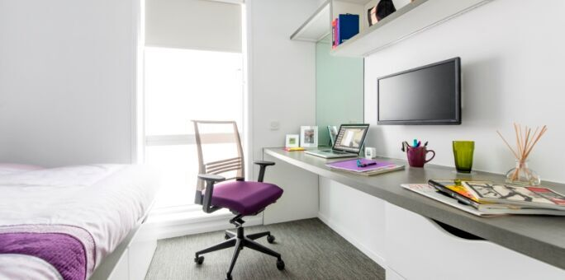

Meals

When the students are on campus, they will eat their meals in the dining hall on site. When they are out on full day excursions, they will be provided with packed lunches. King’s College only serves cold breakfasts.

Meal times*

Breakfast: 08:00 – 09:00

Lunch: 12:45 until 13:45 – for those who have lessons in the morning
14:00 until 15:00 – for those who have lessons in the afternoon

Dinner: 18:30 until 19:30 – for those who have lessons in the afternoon
19:30 until 20:30 – for those who have lessons in the morning

If we are aware in advance, we can advise the catering staff of any dietary requirements or allergies and the canteen staff can cater to these.

*Mealtimes are subject to change

King’s College - Sample Menu
 | Monday |  | Tuesday | Wednesday | Thursday | Friday | Saturday | Sunday
Breakfast |  | Croissants  Toast, Cereal, Yoghurt  Butter and Jams | Croissants  Toast, Cereal, Yoghurt  Butter and Jams | Croissants  Toast, Cereal, Yoghurt  Butter and Jams | Croissants  Toast, Cereal, Yoghurt  Butter and Jams | Croissants  Toast, Cereal, Yoghurt  Butter and Jams | Croissants  Toast, Cereal, Yoghurt  Butter and Jams | Croissants  Toast, Cereal, Yoghurt  Butter and Jams  Full English Breakfast
Lunch  *(V) Vegetarian option available |  | Beef Lasagne /  Vegetable  Lasagne (v)  Selection of Fresh Vegetables  Jacket Potatoes/  Salad Selection  Soup of the Day  with Bread  Pasta & Sauce of the Day  Hummus & Roasted Vegetable Baguette (v) | Coq au Vin  Risotto with Charred Leeks (v)  A Selection of Fresh Vegetables  Jacket Potatoes/  Salad Selection  Soup of the Day  with Bread  Pasta & Sauce of the Day  Chicken Pizza or Mediterranean Veg Pizza (v) | Steak & Guinness  Sausages /  Quorn Sausages (v)  Potatoes & Gravy  A Selection of Fresh Vegetables  Jacket Potatoes/  Salad Selection  Soup of the Day  with Bread  Pasta & Sauce of the Day  Tuna & Sweetcorn Baguette  Cheese Baguette (v) | Beef Stir Fry/  Vegetable Chow Mein (v)  Noodles  A Selection of Fresh Vegetables  Jacket Potatoes/  Salad Selection  Soup of the Day  with Bread  Pasta & Sauce of the Day  BBQ Chicken or Meatball Panini  Brie & Cranberry or Roasted Vegetable Panini (v) | Battered or Grilled Haddock/  Mushroom Carbonara (v)  A Selection of Fresh Vegetables  Jacket Potatoes/  Salad Selection  Soup of the Day  with Bread  Pasta & Sauce of the Day  Southern Fried Chicken Pieces & fries  Pepper & Bean Burritos (v) | Sweet and Sour Chicken  Chilli / Pepper Frittata (v)  A Selection of Fresh Vegetables  Jacket Potatoes/  Salad Selection  Soup of the Day  with Bread  Pasta & Sauce of the Day  BLT Baguette or Beef Baguette  Spiced Falafel and Spinach Wrap (v) | Cheddar Roast (v)  Roast  Potatoes  A Selection of Fresh Vegetables  Jacket Potatoes/  Salad Selection  Soup of the Day  with Bread  Pasta & Sauce of the Day  Tuna or Cheese & Bacon Panini  Cheese & Tomato or Soft Cheese & Pepper Panini (v)
Dinner  *(V) Vegetarian option available |  | Chilli  Lentil Cakes (v)  Quarter Pounder Burger /  Spicy Bean Burger (v)  Fries / Cous Cous  A Selection of Fresh Vegetables and salad  Soup of the Day  With Bread  Pasta & Sauce of the Day | Beef & Mushroom Pie /  Butternut Squash Pie (v)  Chicken Nuggets /  Vegetable Spring Rolls (v)  Mash Potato, Rice  A Selection of Fresh Vegetables  Salad  Soup of the Day  with Bread  Pasta & Sauce of the Day | Chicken Tagine /  Bean and Squash Tagine (v)  Fish Goujons /  Vegetable Nuggets (v)  Fries, Cous Cous  A Selection of Fresh Vegetables  Salad  Soup of the Day  with Bread  Pasta & Sauce of the Day | Roast Chicken  Tortellini / Ricotta (v)  Hot Dogs  Vegetarian / Hot Dogs (v)  Roast Potatoes,  A Selection of Fresh Vegetables  Salad  Soup of the Day  with Bread  Pasta & Sauce of the Day | Chilli Con Carne /  Vegetarian Sausage Jambalaya  (v)  Pasties  Cheese and Onion Pasties (v)  Fries, Rice  A Selection of Fresh Vegetables  Salad  Soup of the Day  with Bread  Pasta & Sauce of the Day | Thai Fish Cakes  Broccoli / Cheddar Quiche (v)  Pepperoni Pizza /  Margarita or Mediterranean Veg Pizza (v)  Wedges, Noodles  A Selection  of Fresh Vegetables Salad  Soup of the Day  with Bread  Pasta & Sauce of the Day | Chicken Tikka /  Chick Pea & Lentil Dahl (v)  Chicken Burger /  Spicy Bean Burger (v)  Fries, Rice  A Selection of Fresh Vegetables  Salad  Soup of the Day  with Bread  Pasta & Sauce of the Day
Pudding |  | Pudding | Mousse | Ice Cream | Sponge & Custard | Ice Cream | Caramel Heaven | Ice Cream

Technology

Wi-fi is available in all the houses and parts of the campus and is password protected. We normally only give this password out to Group Leaders / adults due to it being a university campus with limited firewall security. It is at the Group Leader’s discretion whether they give these details to their students.
There is computer access on campus and you will have access to this on a timetabled basis.
There are no public phones on site.

Security

There is extensive CCTV coverage on campus and duty security officers 8am - 9pm as well as overnight security officers 8:30pm – 8:30am.

Emergency contacts: Each student will be given a wristband when they arrive, and this will have the following emergency telephone number printed on it: 00 44 1244 567695. If you need to contact the centre in the event of an emergency please call this number and follow the options for the relevant centre, this will then put you through to the person on duty.

Certain basic guidelines are common to all centres and students. Students should:
- Never walk away alone!
- Never leave the residence without permission in the evening!
- Always make sure they have understood when and where the meeting point is whilst
out on excursions!
- Always wear their identification lanyard and their UKLC wristband! *
*students found not wearing their lanyard or wristband will be fined £1

Safety

- Remember that there is a 24-hour emergency telephone number on the wristband (0044 1244 567695) and that the number for the emergency services (Ambulance/Police/Fire) in England is 999, or the single emergency number for the EU including the UK is 112 or you can call 101 to report a crime where you do not need an emergency response
- The police are there to help and protect and can be asked for assistance!
- Never respond to someone if you feel threatened, simply walk away!
- Always give your money to the UKLC management team to put in the safe and never to carry large amounts of cash around!
- Be careful crossing the road. Remember that in the UK we drive on the left!
- If you are ill or need a doctor, tell a member of UKLC staff immediately!
- Keep all windows closed when not in your bedrooms!
Insurance and valuables
Although all houses will be accessed via swipe cards, it is suggested that students try to avoid bringing very expensive items with them. If they are bringing valuables with them, it essential that they have sufficient insurance to cover any loss of damage as neither the centre nor the company can be held responsible if anything goes missing. The Centre Manager will have access to a safe if it is required.

Teaching

We know how important it is for each individual student to find their own path in language learning. We use a wide range of methods to engage and stimulate our students. This is why we have created a curriculum based on the students’ age, level and needs, structured into four different programmes:
FUN (ages 8-10)
Engaging lessons that offer a wide range of materials and activities specific for our young learners, making games into lessons and lessons into games. Available in levels A1-B1.

CONNECTION (ages 10-13)
Dynamic lessons covering a variety of topics and media, designed to engage students using tools native to the fast-paced world they are growing up in. Available in levels A1-C1.

ACTION (ages 13-16)
Lessons tailored for learners stepping into their teenage years. This programme focuses on activating students’ knowledge and competencies to balance developing a personal voice while contributing effectively to a team. Available in levels A1-C1.

PURPOSE (ages 16-18)

Lessons tailored for our students approaching adulthood, designed to kickstart their lives not only as maturing youths but also as forward-thinking global citizens. Available in levels A1-C2.

The Connection, Action, and Purpose programmes consist of three different lessons a day:

FOCUS ON LANGUAGE

These lessons aim to empower our students’ linguistic awareness and capabilities by working on all language skills (reading, writing, listening, speaking) and systems (grammar, phonology, lexis, discourse), as well as using materials relevant to exam preparation (KET, PET, FCE, CAE, TOEFL, IELTS, GESE).

FOCUS ON LEADERSHIP

This programme is designed to equip students with essential 21st-century skills, focusing on leadership development, communication and teamwork. Students build the confidence and competencies needed to grow into empowered young adults.

FOCUS ON CULTURE
These lessons combine CLIL and British culture, allowing students to use English to explore a range of disciplines, including art, literature, natural sciences, as well as the history and geography of the UK.

Placement tests
We offer classes at four levels, from elementary to advanced. Students take a placement test on their first day of classes to ensure they are placed at the correct level.

Once the tests have been marked, students won’t be told their score unless they specifically ask for it but will be placed into a class based on these results.

If students are not happy with their level, they can speak with the Course Director who will decide if it is necessary for the student to change levels.

We always try to split groups into different classes to mix nationalities, but this does depend on their levels and the numbers of students that we have on site.

We will provide all course materials including a journal and a pen.

Students are taught in class sizes up to 16.

Programme

All UKLC summer programmes include:

- 15 hours of English lessons
- Full board accommodation in residence
- Full programme of excursions and evening entertainment
- 1 free leader for 15 students
- Placement test on arrival and End of Course Certificate

A typical day for students

08:00 – 09:00 Breakfast

09:00 – 10:00 Lesson 1

10:00 – 10:15 Break

10:15 – 11:15 Lesson 2

11:15 – 11:30 Break

11:30 – 12:30 Lesson 3

12:30 – 13:30 Lunch

14:00 – 17:30 Afternoon Activities

18:30 – 19:30 Dinner

20:00 – 22:00 Evening Activities

22:00 Bedtime

This centre runs on a ‘zig-zag’, meaning the order of lessons and multi-option activities/excursions will change after a week. See example below.

Kings College, London Sample Programme - Summer 2025

 |  | Morning | Afternoon | Evening
Week 1 | Tuesday | English Test | Tate Modern Gallery | Trashion Show
 | Wednesday | Lessons | The British Museum & Covent Garden | Message Disco
 | Thursday | Lessons | The National Gallery | Film Night
 | Friday | Lessons | Notting Hill & Portobello | Red vs Blue
 | Saturday | Lessons | The National Science Museum | Paparazzi
 | Sunday | London – Buckingham Palace, Downing Street, Houses of Parliament, Big Ben & London Eye |  | Quiz Night
 | Monday | Knightsbridge, Hyde Park & Harrods |  | Oscars or Conversation Club
Week 2 | Tuesday | National Portrait Gallery & Leicester Square | Lessons | Treasure Hunt
 | Wednesday | National History Museum | Lessons | Karaoke or Conversation Club
 | Thursday | Greenwich with National Maritime Museum | Lessons | Mini Olympics
 | Friday | London Museum Docklands | Lessons | Film Night
 | Saturday | Cambridge Walking Tour with the Fitzwilliam Museum | Lessons | Talent Show
 | Sunday | Camden Town, Market & Regent’s Canal |  | Leaving Disco
 | Monday | Departures

Please note: This is a sample programme and may be subject to change. It may also be necessary to operate a zig zag programme of morning / afternoon lessons.

Facilities

Facilities on site:
- Recreational and social areas
- There are no sports facilities on site

Evening entertainment

The UK Language Courses staff plan fantastic activities to make sure the students enjoy their evenings. For example: discos, quizzes, fashion shows, blind date, sports tournaments etc. We ask Group Leaders to encourage students to participate as much as possible and to communicate any special ideas or requests from students.

Here are a few brief descriptions of just some of our activities for students to join in on:

Around the World
Consists of a number of different stations based on activities from different countries. One staff member will be placed at each activity station. They will each represent a country and have to create an activity related to that country (for example: New Zealand – The Haka). Students will be divided into groups and given a time for each station. Students will visit each station.

Oscars Night
Involves students watching a number of scenes from selected films. They will have the chance to re-enact a famous selected scene. Creating their own script, which must be in English and costumes (out of various given equipment). Scenes will be shown on a big screen for everyone to watch. Awards will be given by UKLC staff for the best reproduction.

Speed Dating
Enables students from mixed nationalities to socialise and get to know each other whilst improving their spoken English. Students will have a short period of time to have a conversation on their interests, hobbies etc. Once the given time finishes they will move to another student and begin the same process again.

Talent Show
Gives students the opportunity to perform talents such as singing, dancing and acting in front of the whole centre! Sign-up sheets will be available in the centre a few days before the event. There will be judges who will score the performances and give positive feedback to each student who performs on the evening.

We look forward to welcoming you to Kings College London in summer 2026!







